Assignment Title: Web API using .NET Core with Swagger and Postman
Objectives:
Demonstrate Swagger installation to WebAPI and display the API documentation in the browser. This involves installing the Swashbuckle.AspNetCore NuGet package, using [ProducesResponseType] in controller methods, configuring AddSwaggerGen in Program.cs, and enabling UseSwaggerUI.
Demonstrate the usage of Postman to interact with WebAPI methods. This includes understanding the structure of requests, using headers and body with JSON, choosing the HTTP method (GET, POST), organizing requests into collections, and interpreting the response.
Demonstrate usage of route customization and explain the Name attribute in HTTP request attributes. Explain how ActionName can help support multiple methods with the same HTTP verb. A simple WebAPI is created with Read and Write operations.
Part 1: Web API using .NET Core with Swagger
Created a new .NET 6/7/8 Core Web API project using:
dotnet new webapi -n MySwaggerAPI
cd MySwaggerAPI
dotnet add package Swashbuckle.AspNetCore
Configured Swagger in Program.cs:
using Microsoft.OpenApi.Models;

var builder = WebApplication.CreateBuilder(args);
// Add services to the container.
builder.Services.AddControllers();
builder.Services.AddEndpointsApiExplorer();
builder.Services.AddSwaggerGen(c =>
{
c.SwaggerDoc("v1", new OpenApiInfo
{
Title = "Swagger Demo",
Version = "v1",
Description = "TBD",
TermsOfService = new Uri("https://example.com/terms"),
Contact = new OpenApiContact
{
Name = "John Doe",
Email = "john@xyzmail.com",
Url = new Uri("https://www.example.com")
},
License = new OpenApiLicense
{
Name = "License Terms",
Url = new Uri("https://www.example.com")
}
});
});
var app = builder.Build();
app.UseSwagger();
app.UseSwaggerUI(c =>
{
c.SwaggerEndpoint("/swagger/v1/swagger.json", "Swagger Demo");
});
app.UseHttpsRedirection();
app.UseAuthorization();
app.MapControllers();
app.Run();

StudentController.cs
using Microsoft.AspNetCore.Mvc;
using MySwaggerAPI.Models;

namespace MySwaggerAPI.Controllers
{
[ApiController]
[Route("api/[controller]")]
public class StudentController : ControllerBase
{
private static List<Student> students = new List<Student>
{
new Student { Id = 1, Name = "Alice", Course = "BCA" },
new Student { Id = 2, Name = "Bob", Course = "MCA" }
};
[HttpGet]
[ProducesResponseType(200)]
public ActionResult<IEnumerable<Student>> GetStudents()
{
return Ok(students);
}
[HttpPost]
[ProducesResponseType(201)]
public ActionResult<Student> AddStudent(Student student)
{
student.Id = students.Count + 1;
students.Add(student);
return CreatedAtAction(nameof(GetStudents), new { id = student.Id }, student);
}
}
}

Student.cs
namespace MySwaggerAPI.Models
{
public class Student
{
public int Id { get; set; }
public string Name { get; set; } = string.Empty;
public string Course { get; set; } = string.Empty;
}
}
Output in Swagger
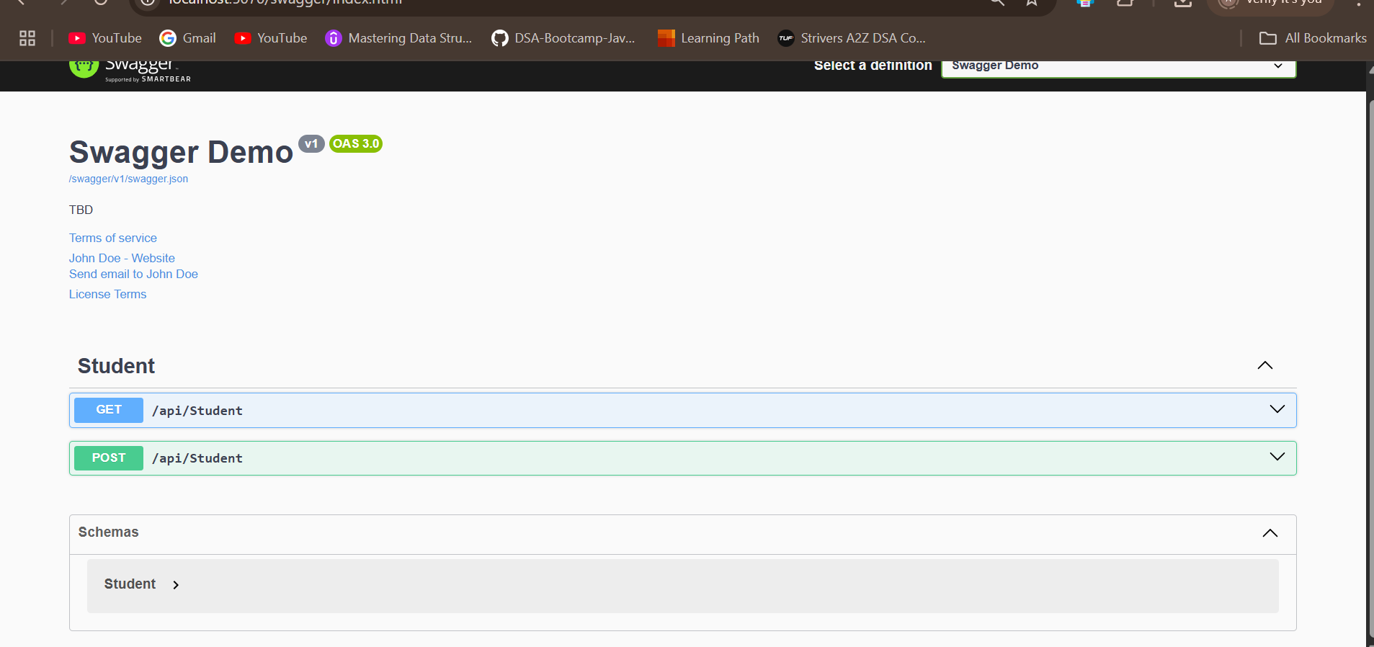
Part 2: Using Postman to Test Web API
After successfully running the Web API project locally using the dotnet run command, the API was accessible at http://localhost:5070. Postman was used to send HTTP requests to this API and view the responses.
To retrieve the list of students, a GET request was made to http://localhost:5070/api/Student. In Postman, the request type was set to GET, and no body or headers were required. After clicking the Send button, the response was received in JSON format with HTTP status code 200 OK. The body of the response contained the existing list of student objects, confirming that the GET method in the controller was working correctly.
To add a new student, a POST request was made to the same endpoint: http://localhost:5070/api/Student. The request method was set to POST. In the Body section of Postman, the request type was set to raw and the format to JSON. The JSON object entered into the body looked like this:
{
"id": 3,
"name": "Charlie",
"course": "Chemistry"
}
After clicking Send, the server responded with status code 201 Created. The response body returned the newly added student object, confirming that the POST method executed successfully and added the data to the list.
The status codes (200 for GET and 201 for POST) were shown on the right-hand side of the Postman response pane. The list of students including the newly added one was confirmed using a follow-up GET request.
Postman Output:
GET Request URL:
http://localhost:5070/api/Student
Response Status: 200 OK
Response Body:
[
{
"id": 1,
"name": "Alice",
"course": "Math"
},
{
"id": 2,
"name": "Bob",
"course": "Physics"
},
{
"id": 3,
"name": "Charlie",
"course": "Chemistry"
}
]
POST Request URL:
http://localhost:5070/api/Student
Request Body:
{
"id": 3,
"name": "Charlie",
"course": "Chemistry"
}
Response Status: 201 Created
Response Body:
{
"id": 3,
"name": "Charlie",
"course": "Chemistry"
}
Part 3: Modifying Route Attribute and Using ActionName
To customize the URL for the controller, the [Route] attribute was modified in the StudentController class. Initially, the controller was accessible at api/Student. By changing the route attribute to [Route("api/Emp")], the controller was now available at api/Emp instead.
After making this change and rerunning the project, Postman was used again to verify that the new route was functioning. A GET request was sent to http://localhost:5070/api/Emp. This returned the same list of students as before, confirming that the controller could still be accessed correctly but through the new route.
This modification demonstrates how custom routes can make API endpoints more meaningful and user-friendly. The [Route] attribute can be used to rename or organize controllers without changing the internal logic.
In addition, the ActionName attribute can be used to give friendly names to methods or resolve naming conflicts when multiple actions share the same HTTP verb. Although not used in this specific example, it provides a powerful mechanism for method-level customization in Web APIs.
Postman Output After Route Change:
GET Request URL:
http://localhost:5070/api/Emp
Response Status: 200 OK
Response Body:
[
{
"id": 1,
"name": "Alice",
"course": "Math"
},
{
"id": 2,
"name": "Bob",
"course": "Physics"
},
{
"id": 3,
"name": "Charlie",
"course": "Chemistry"
}
]
Conclusion
Successfully created a .NET Core Web API with Swagger UI and integrated it with Postman for testing. Demonstrated route customization, response annotations, and basic CRUD operations.

